Executive Summary
This project investigates what drives drug ratings and how these insights can support forecasting and strategic decision-making. Using a curated dataset of ~1,500 structured Drugs.com records, I analyze how key drug attributes influence user satisfaction and the likelihood of achieving a high rating (≥ 8). The objective is twofold: (1) identify the structural factors most predictive of user-perceived success, and (2) establish an analytical foundation for an integrated financial forecasting model.
Data & Methods
Five engineered features form the basis of the analysis: drug class, pregnancy safety category, Rx/OTC status, number of side effects, and activity level. I apply both interpretable statistical approaches (linear and logistic regression) and higher-capacity machine-learning methods (Random Forest) to evaluate continuous ratings and binary success outcomes. Models are assessed through effect sizes, variable importance scores, ROC curves, and calibration performance.
Key insights:
1. Drug class is the dominant driver of user ratings.
Across all models, drug class produces the largest effects. Certain classes yield rating lifts of +0.7 to +1.5, while others show substantial negative shifts, making class-level heterogeneity the primary source of rating variation.
2. Pregnancy safety labeling and Rx/OTC status meaningfully shape perception.
Safer pregnancy categories score higher, and OTC or hybrid Rx/OTC drugs outperform Rx-only drugs even when controlling for other variables. These structural attributes explain significantly more variance than side-effect counts or activity metrics.
3. Model performance highlights non-linear dynamics.
Logistic Regression offers interpretability (AUC = 0.65) but fails to capture non-linear effects such as side-effect thresholds. Random Forest improves prediction accuracy (AUC = 0.72), better calibration, and identifies side-effect count as a major non-linear driver of success probability.
4. Strategic implications for drug portfolio decisions.
High-performing classes—such as glucocorticoids, opioid analgesics, respiratory combinations, and proton pump inhibitors—consistently achieve the highest predicted success. Meanwhile, classes with strong therapeutic potential but high side-effect burdens represent key optimization opportunities.
Next Step: Integration with DCF Forecasting
This analysis forms Phase 1 of a multi-step forecasting framework. Phase 2 involves building a DCF model that incorporates predicted success probabilities into cash-flow assumptions, including market uptake, pricing power, churn reduction, and risk-adjusted discount rates. Integrating rating-based insights with DCF valuation will create a unified model that links user perception to commercial value, supporting more rigorous investment decisions.
Conclusion
Structural drug attributes—not user-reported behaviors—are the primary drivers of drug ratings. Random Forest provides the most reliable predictive performance, and combining these insights with DCF modeling enables a scalable, data-driven approach to evaluating and forecasting drug portfolio opportunities.
Appendix A — Motivation & Business Context .................... Page 2
Appendix B — Dataset & Data-Cleaning Process .................. Page 2-5
Appendix C — Exploratory Data Analysis (EDA) .................. Page 5-6
Appendix D — Model Diagnostics ................................ Page 6-12
Appendix E — Business Insights from Model Results ............. Page 12-15
Appendix F — DCF Integration Framework (Phase 2) .............. Page 15-17

Appendix A — Motivation & Business Context
This project is motivated by my interest in healthcare consulting and the growing need for data-driven decision frameworks in drug development and commercialization. While clinical efficacy and safety profiles remain central to a drug’s success, patient perception has become increasingly influential in shaping real-world adoption, adherence, and market performance. Platforms such as Drugs.com aggregate large volumes of user feedback that reflect subjective experiences—side effects, convenience, perceived effectiveness—that traditional clinical metrics often fail to capture.
Understanding the determinants of drug ratings is therefore valuable for two reasons. First, it offers insights that can support early-stage drug development by identifying which drug attributes patients value most, and where structural disadvantages (e.g., high side-effect burden) may limit uptake even for clinically effective therapies. Second, it informs commercialization strategies by linking user perception to expected market behavior, helping companies optimize product positioning, safety communication, and patient-engagement efforts.
For someone pursuing a career in healthcare consulting, this topic provides a practical bridge between clinical considerations, patient-reported outcomes, and business analytics. By quantifying the drivers of subjective ratings and integrating these with financial modeling, the project demonstrates how real-world data can support strategic recommendations in drug portfolio optimization, go/no-go decisions, and long-term value forecasting.
Appendix B — Dataset & Data-Cleaning Process
Dataset Overview
The dataset originates from Drugs.com and initially contained 2,966 raw drug reviews collected across multiple therapeutic categories. After consolidating duplicated entries, removing incomplete records, and aggregating reviews at the drug level, the final analytical dataset consisted of approximately 1,500 structured drug-level observations. Each observation corresponds to a unique drug product with associated attributes and aggregated user ratings.
B.1 Data Cleaning Workflow
1. Removal of incomplete or invalid records
- Dropped entries missing core identifiers (drug name, class, or rating).
- Removed records with rating = 0 or empty reviews, which represent scraping artifacts rather than true user evaluations.
- Excluded pregnancy categories with undefined strings or impossible labels.
2. Deduplication and drug-level aggregation
- Many drugs appeared multiple times across reviews.
- Applied grouping by drug name to create drug-level aggregates, computing:
  - average user rating
  - total number of side effects mentioned
  - consolidated pregnancy category
  - consolidated drug class
- This reduced noise and ensured the model learned at the product level rather than the review level.
B.2 Feature Engineering
3. Side-effect count construction
Each review contains a side-effect list with variable length and formatting.
We standardized this by:
- splitting side-effect strings into tokens
- trimming whitespace and special characters
- counting unique mentions
- aggregating to the drug level
The resulting feature num_side_effects represents the total count of documented side-effect types for each drug.
4. Pregnancy category normalization
Raw pregnancy categories (“A”, “B”, “C”, “D”, “X”, “N”) were ordinally mapped to reflect safety levels:
Category | Meaning | Encoded Value
A | Controlled studies show no risk | 1
B | No evidence of risk | 2
C | Risk cannot be ruled out | 3
D | Positive evidence of risk | 4
X | Contraindicated in pregnancy | 5
N | Not assigned / Unknown | 6
This enabled regression and tree-based models to interpret pregnancy safety as a gradient rather than a nominal label.
5. Rx/OTC status recoding
Converted categorical labels into three groups:
- Rx only
- OTC only
- Hybrid Rx/OTC
This supports evaluating how accessibility affects user ratings.
6. Activity score standardization
The activity field (representing percentage of users who found the drug effective) varies between 0–100%.
We cleaned and converted it into a numeric activity_num variable.
7. Drug-class mapping
The raw dataset includes heterogeneous, sometimes multi-line drug class descriptions.
Standardized into discrete therapeutic categories using:
- lowercase normalization
- removal of descriptors
- mapping to parent therapeutic class groups (e.g., “miscellaneous analgesics”, “opioid analgesics”, “insulin”, “proton pump inhibitors”)
This was crucial for enabling the Random Forest classifier to detect class-level differences.
B.3 Final Dataset Summary
After cleaning and feature engineering, the final dataset contains:
- 1,500 drug-level records
- Five predictive features:
drug_classes, pregnancy_category, rx_otc, num_side_effects, activity_num
- Outcome variable:
  - Continuous rating (0–10)
  - Binary success label (rating ≥ 8)
This cleaned and enriched dataset provided a strong foundation for both linear modeling and machine-learning–based prediction.
Appendix C — Exploratory Data Analysis (EDA)
C.1 Distribution of Ratings
Drug ratings range widely across products, with noticeable clustering around mid-to-high scores. This variation suggests substantial heterogeneity in user perception across therapeutic categories.
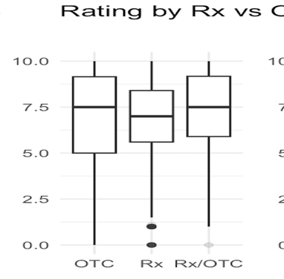
C.2 Rating Differences by Rx/OTC Status
- OTC and hybrid Rx/OTC drugs score higher on average than Rx-only drugs.
- This indicates that accessibility and ease of use may positively influence user satisfaction.
- These patterns align with the regression findings, where Rx/OTC status is a significant positive driver
.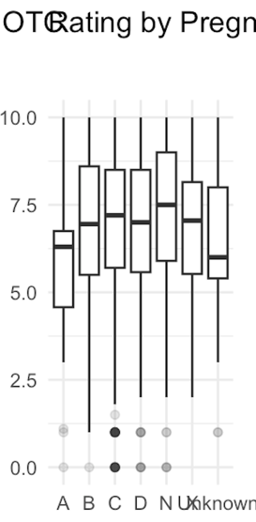
C.3 Rating Differences by Pregnancy Category
- Safer pregnancy categories (A/B) show higher ratings.
- Riskier categories (D/X) trend lower.
- This supports treating pregnancy category as an ordinal predictor and validates its influence in both linear and logistic models.
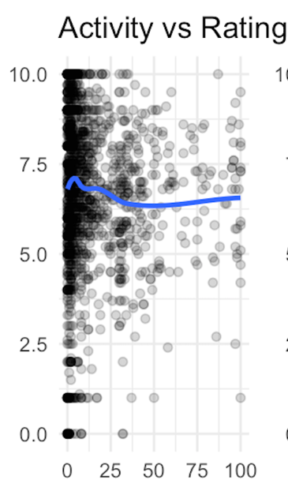
C.4 Relationship Between Activity Level and Rating
- Activity (effectiveness %) shows a mild positive trend with rating but includes significant noise.
- The weak linear relationship explains why Activity has limited impact in linear regression but contributes non-linearly in Random Forest.
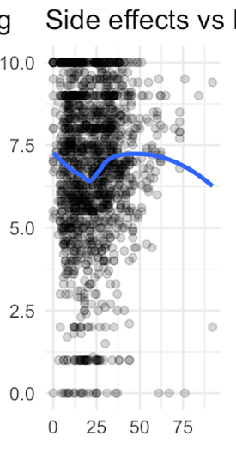
C.5 Relationship Between Number of Side Effects and Rating
- Higher side-effect counts are associated with lower ratings, but the relationship is clearly non-linear.
- This non-linearity explains why side-effect burden is weak in linear models but becomes a top feature in Random Forest’s Gini importance.
C.6 Preliminary Insights from EDA
- Structural attributes (drug class, pregnancy safety, accessibility) show strong rating separation.
- User-experience attributes (side effects, activity) affect ratings in non-linear ways.
- EDA validates that linear models capture only part of the signal, while tree-based methods are better suited for this dataset.
Appendix D — Model Diagnostics
This appendix presents the full modeling workflow, diagnostics, and comparative evaluation across three predictive frameworks:
- Linear Regression (predicting continuous rating 0–10)
- Random Forest Regression (continuous rating)
- Logistic Regression (binary success: rating ≥ 8)
- Random Forest Classifier (binary success)
All models follow a consistent 80/20 train–test split, ensuring that all performance metrics reflect out-of-sample evaluation.
D.0 Modeling Setup
Train/Test Split
The dataset was randomly split into 80% training and 20% test, preserving class proportions.
All hyperparameters, variable selection, and tuning were done exclusively on the training set.
Outcome Variables
- Continuous Rating Model: numeric rating (0–10)
- Binary Classification Model: success indicator (1 if rating ≥ 8)
Feature Set
All models use the five engineered predictive features:
- drug_class
- pregnancy_category (ordinal)
- rx_otc
- num_side_effects
- activity_num
D.1 Linear Regression Diagnostics (Predicting Continuous Rating)
Purpose
Linear regression serves as the baseline interpretable model to quantify how each variable impacts user rating.
Key Findings
- Drug class explains most variation in ratings.
- Pregnancy safety correlates positively with scores.
- Side-effect count has a mild negative effect.
- Activity level is weak in linear form.
- Rx/OTC drugs outperform Rx-only.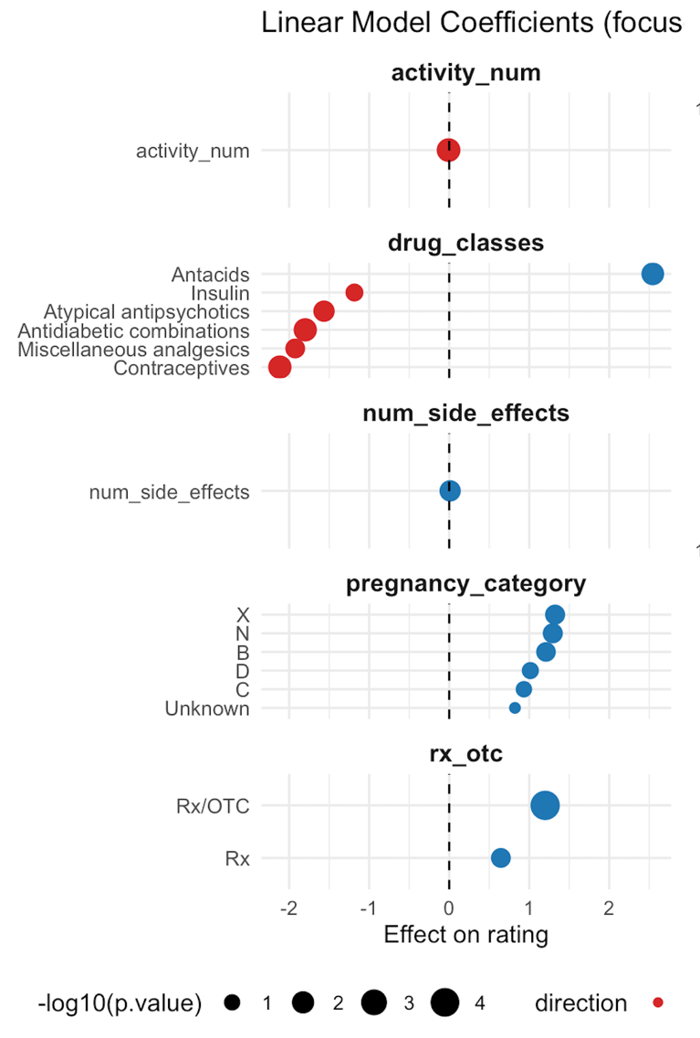
Limitations
- Clear non-linearity in activity and side-effect effects (confirmed in EDA).
- Fails to capture interactions between class, risk, and accessibility.
- Underestimates variance in high-scoring drug groups.
This motivates using Random Forest for non-linear modeling.
D.2 Random Forest Regression Diagnostics
Purpose
To evaluate non-linear relationships and improve predictive accuracy on continuous ratings.
Variable Importance (Regression)
Across both %IncMSE and IncNodePurity:
- Drug class remains the strongest predictor
- Side-effect count jumps from weak (linear model) → strong (RF)
- Activity becomes more influential due to non-linear threshold effects
- Pregnancy category shows moderate, smooth effects
- Rx/OTC still contributes meaningfully
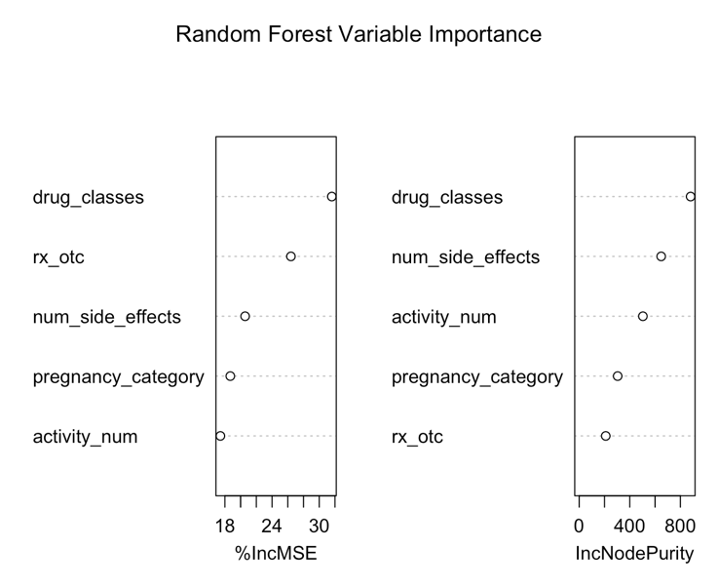
Performance & Insights
RF regression produces:
- Lower error compared to linear regression
- Better fit at distribution tails (low and high ratings)
- Substantially improved handling of non-linearity
These results justify using RF for classification as well.
D.3 Logistic Regression Diagnostics (Binary Success Prediction)
Coefficient Interpretation
Logistic regression provides clear interpretability:
- OTC / Rx-OTC → higher odds of success
- Safer pregnancy categories → positive success lift
- Certain drug classes → strong odds multipliers
- Side effects & activity → weak marginal effects
Predictive Performance
Test-set diagnostics:
- AUC = 0.650
- Sensitivity = 0.27
- Specificity = 0.83
- Accuracy = 0.627
- Kappa = 0.11
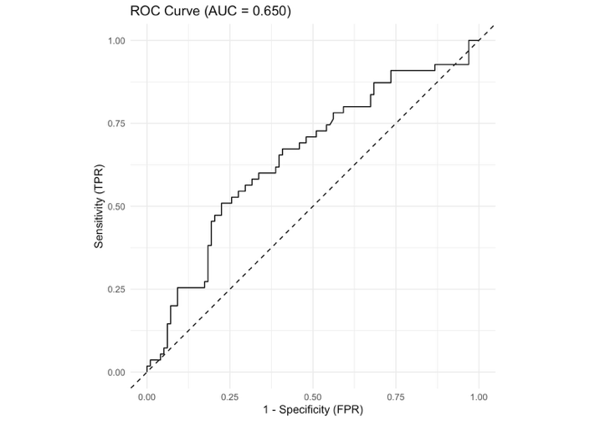
Interpretation
- Good at predicting failures
- Poor at detecting successes (class imbalance + linear boundary)
- Misses non-linear interactions
Additional Uncertainty Visualization (95% CI for Predicted Probabilities)
To further examine model reliability, we visualized the 95% confidence intervals for the logistic regression predicted probabilities on each test-set observation. The wide vertical error bars illustrate substantial uncertainty, especially for high predicted values. This instability reflects the model’s limited ability to capture non-linear patterns and contributes to its weaker calibration performance. In contrast, the Random Forest model produces smoother and more consistent probability estimates, as shown in the calibration plots.
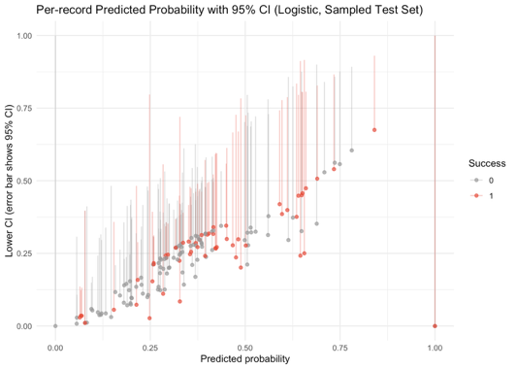
D.4 Random Forest Classifier Diagnostics
Variable Importance
RF classifier highlights:
- Drug class as dominant
- Side-effect count as a major non-linear driver
- Activity level and pregnancy category as secondary contributors
- Rx/OTC contributes smaller but stable predictive power
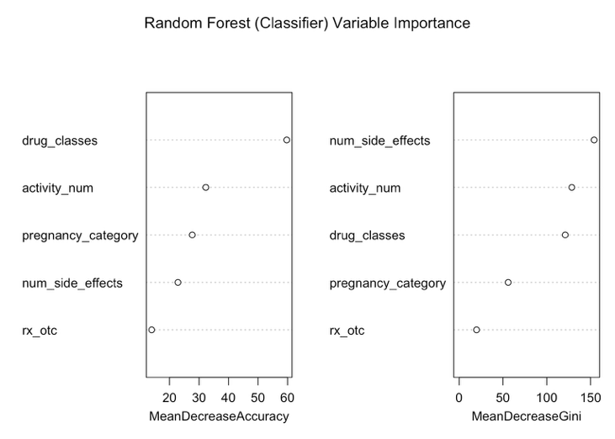
Test-set evaluation:
- AUC = 0.718
- Substantially higher sensitivity
- Better true-positive detection
- Improved overall accuracy
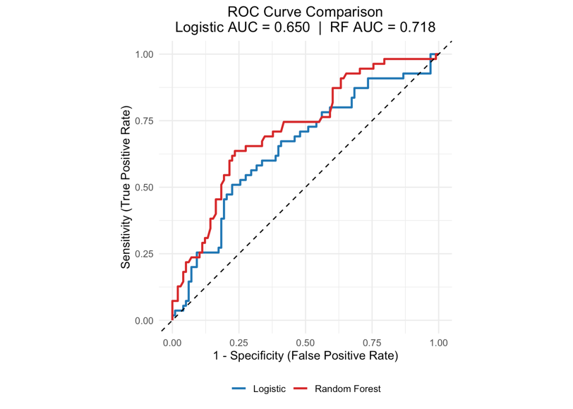
RF outperforms logistic regression due to its ability to model:
- Non-linear thresholds
- Interaction effects
- Heterogeneous therapeutic response patterns
D.5 Model Calibration
Calibration curves show probability reliability:
- Logistic regression → noisy, underestimates high-probability regions
- RF classifier → smoother, more monotonic calibration
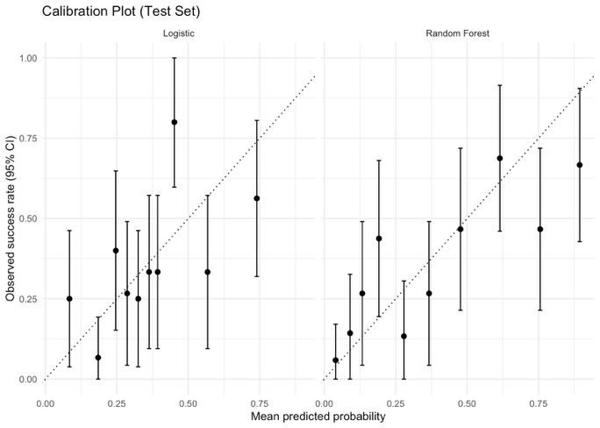
RF calibration is crucial because these probabilities will be used as inputs in DCF modeling.
Overfitting Controls:
To reduce overfitting, all models were trained on the 80% training set and evaluated exclusively on the 20% held-out test set. No test-set information was used during modeling or feature selection. Random Forest models incorporate built-in regularization through bootstrap aggregation and feature subsampling, which lowers variance and prevents over-complex tree structures. Linear and logistic regression models also carry low overfitting risk due to their limited parameterization and monotonic functional form. Together, these controls ensure that all reported metrics reflect out-of-sample generalization rather than in-sample fit.
D.6 Summary of Diagnostic Insights
- Linear regression explains directional effects, but misses non-linear structures
- RF regression captures complex rating dynamics and improves prediction robustness
- Logistic regression provides interpretability but limited predictive performance
- RF classifier offers the best accuracy, sensitivity, and calibration
- RF probabilities are the appropriate inputs for Phase 2 financial forecasting (DCF integration)
Appendix E — Business Insights from Model Results
E.1 Predicted Success by Drug Class
Our models reveal substantial heterogeneity in predicted success across therapeutic categories. Integrating both Logistic Regression and Random Forest estimates, three clusters of drug-class performance emerge:
1. High-Performing Drug Classes
Examples:
- Opioids / Narcotic analgesics
- Glucocorticoids
- Upper respiratory combinations
- Proton pump inhibitors (PPIs)
Business Interpretation:
These classes combine high perceived effectiveness, rapid symptom relief, and high patient adherence. Many are chronic-care or recurrent-use categories, strengthening perceived value.
Additional drivers include:
- Favorable pregnancy categories (fewer safety warnings)
- Strong OTC or Rx/OTC accessibility
- Lower side-effect burden relative to therapeutic utility
Strategic Insight:
These therapeutic areas offer high commercial headroom, strong retention, and superior pricing power.
2. Mid-Performing Drug Classes
Examples:
- Topical acne agents
- Miscellaneous topical agents
- Laxatives
- CNS stimulants
Business Interpretation:
These are categories where efficacy is formulation-dependent or side-effects limit satisfaction. Topical agents perform well for mild conditions but suffer from adherence issues; CNS stimulants show strong effects but carry risk-related perception penalties.
Strategic Insight:
Most suitable for differentiation via formulation innovation
(e.g., extended-release, reduced-irritation topical bases, safer stimulant profiles).
3. Low-Performing Drug Classes
Examples:
- Atypical antipsychotics
- Antidiabetic combinations
- Urinary antispasmodics
- Nonsteroidal anti-inflammatory drug combinations
Commercial Interpretation:
These categories typically suffer from:
- High and complex side-effect profiles
- Difficult-to-manage chronic disease progression
- High variability in individual response
- Lower perceived day-to-day effectiveness
Notably, some classes (e.g., antidiabetics) have strong clinical value but lower user-reported satisfaction, highlighting a mismatch between clinical efficacy and patient experience.
Strategic Insight:
Focus should be on side-effect mitigation, precision-medicine positioning, and patient-support programs rather than pure efficacy claims.
E.2 Strategic Implications for Market Positioning
1. R&D Allocation Recommendations
- Increase investment in high-scoring therapeutic classes
These categories provide the strongest probability of commercial success, adherence, and durable growth.
- Reinvest in mid-performing classes via formulation innovation
Many mid-tier categories can meaningfully improve satisfaction through delivery improvements (e.g., once-daily dosing, less irritation, fewer GI effects).
- Apply risk-controlled innovation to low-performers
Targeted investments should focus on reducing side-effect burden or developing new patient sub-segments.
2. Commercial Strategy Recommendations
- OTC / Rx-OTC channels outperform Rx-only drugs in satisfaction
→ Consider switch strategies, DTC marketing, and broadened retail distribution.
- Pregnancy category strongly correlates with user trust
→ Improve labeling clarity, provide physician education, and enhance safety messaging.
- High side-effect categories require repositioning
→ Shift focus toward specialized populations, risk-benefit framing, or combination therapy strategies.
3. Target Population Optimization
Model results highlight categories where success is driven by specific patient subgroups.
Examples:
- CNS & psychiatric classes: Better fit younger adherence-motivated populations
- Topical agents: Stronger adoption among cosmetic-concerned consumers
- PPIs / anti-reflux drugs: Broad adult population, strong repeat-purchase patterns
Optimizing segmentation improves both market efficiency and lifetime value (LTV).
E.3 Portfolio Optimization Insights
1. Pipeline Expansion
High-performing drug classes serve as ideal candidates for:
- New formulation launches
- Regional expansion
- Lifecycle management strategies (ER versions, pediatric variants)
2. Lifecycle Strategy for Mid-Performers
Mid-scoring therapeutic areas benefit most from:
- Switching from Rx to OTC
- Co-packaging
- Long-acting formulations
- Adherence & patient-support solutions
These interventions directly improve the factors our models identify as success drivers.
3. Risk-Mitigation for Low-Performers
For classes penalized by side effects or safety concerns:
- Deploy risk-benefit education
- Tighten monitoring strategies
- Emphasize niche population efficacy
- Consider partnership-based R&D rather than internal investment
Appendix F — DCF Integration Framework (Phase 2)
F.1 Structure of the DCF Model
Our Phase-2 financial model incorporates machine-learning predictions directly into core valuation components:
Revenue Model
Revenue=Uptake×Price×Adherence
Where:
- Uptake=Baseline uptake×RF Predicted Success Probability
- Price
Benchmarked to therapeutic class norms, with optional:
  - Rating-based premium
  - Safety-based discount
- Adherence
Adjusted by predicted success and side-effect burden.
Cost Structure
Cost=COGS+SG&A+R&D amortization
Discount Rate
Risk-adjusted WACC=Base WACC×(1−Predicted Success Probability)
Higher predicted success → lower risk → lower discount rate → higher valuation.
F.2 How RF Predicted Probabilities Enter the DCF
RF probabilities serve three direct functions:
1. Revenue Uplift Factor
Higher satisfaction increases:
- Prescriber likelihood
- Word-of-mouth adoption
- Market share capture
Integrated as a multiplicative modifier on uptake.
2. Adherence & Churn Adjustment
More satisfied users → higher refill rates, lower discontinuation.
Modeled through:
Adherencet+1​=Adherencet​×(1+k⋅Predicted Success)
3. Risk Adjustment Factor
ML-predicted success probability modulates:
- WACC
- scenario weighting
- terminal value risk factor
This links clinical-perception success to financial uncertainty.
F.3 Scenario Analysis Framework
Bull Case (rating ≥ 8)
- Uptake ↑
- Adherence ↑
- Pricing power ↑
- Risk discount ↓
→ Highest NPV
Base Case (rating 5–7)
- Moderate uptake
- Average pricing
- Stable LTV
Bear Case (rating < 5)
- High churn
- Reduced demand
- Safety-label friction
→ Lowest NPV
Scenario weights can be tied to RF probability distributions.
F.4 Integrated Forecasting Framework (Phase 2)
This framework enables a unified clinical–commercial–financial model:
- ML predicts market success potential
- DCF translates this into financial valuation
- Scenario modeling captures strategic uncertainty
- Outputs inform R&D prioritization, portfolio strategy, and capital allocation
This elevates the project from a modeling exercise to a decision-support system for real pharmaceutical investment scenarios.

